

**FEATURE**

**Valentine’s Day**

**Communication & Empathy**

Joe H. Zerbey VI

The human experience is defined by relationships we forge with others. Those we meet are a window into ourselves, for what are we if not what others help us become? Even the most independent people learn a lot about themselves by being with others. We are taught to respect our strengths, be aware of our weaknesses, and find our boundaries. On our paths, we are destined to find challenges, but with our ability to communicate and work through problems, we can topple those challenges and find happiness, excitement, and peace.

In this feature, I would ask that readers take some time to think about their various relationships and how they affect their lives. Whether it is a friend or family member, communication, honesty, and empathy are invaluable tools for strengthening those bonds. This Valentine’s Day, I implore you to reach out to people in your lives and talk about everything you’re feeling, and listen to how they are feeling in return. Being open like this creates a vulnerability of sorts, but

can lead to a deeper understand of yourself and others. If there have been difficulties between yourself and someone you care about, it is a good time as any to start talking it out. A genuine desire to understand someone else will allow them to feel more inclined to understand you, but just keep in mind that someone’s ability to *want* to understand someone else will vary, and may take more time and require patience.

Empathy is simultaneously one of the easiest and one of the hardest tools to utilize. Some can find no trouble feeling as another does, but that isn’t always so simple. We all have been dealt a different hand and carry many experiences, so what we’ve been through will drastically differ from someone else. This is why it will always come back to just having a conversation, listening, wanting to understand. Love comes in all kinds of forms. The time we give to others, the patience we offer, that is love. This Valentine’s Day, let’s use that love to make sure we’re doing our best to understand each other and find common ground. We all have the power to make peace within ourselves, and it all starts with taking the first step.

Please feel free to provide feedback on this newsletter’s content to either myself at [jzerbey@longviewithaca.org](mailto:jzerbey@longviewithaca.org) or Christina

Sterling at [csterling@longviewithaca.org](mailto:csterling@longviewithaca.org). We want to keep the newsletter relevant, fun

and to the liking of those who read it. Thank you again for your support.

**SPIRITUAL GUIDANCE NEWS**

Brooke Newell

**February preachers:**

Feb. 2 - The Rev. Geri Judd, Newfield

United Methodist Church

Feb. 9 - The Rev. Paul Rack, Trumansburg

Presbyterian Church

Feb. 16 - The Rev. Nancy Didway, Dryden

Presbyterian Church

Feb. 23 - Major "Sunshine", the Salvation

Army

**"Stretch Your Spirit"**

On Monday, February 17, we will visit the Buddhist monastery from 1:30-3:00 pm for a festival of music.  Look for the sign-up sheet on the bulletin board in the craft room.

On Thursday, February 27, the local Lutheran choir will join us again for "Compline" (that is, sung evening prayers) at 6:45 in the auditorium.

**Shabbat Worship**

The Ithaca College students will visit on Fridays, February 7 and February 21, at 3:30 pm for Shabbat. Everyone is welcome to participate in the Chapel.

**RECREATION**

Bree Nash

**February happenings**

2/3 – Food Committee Meeting (1:30PM),

Holiday Bazaar Meeting (3:30PM)

2/4 – Coffee with Cheryl (2:30PM), Music

with the Fortnight Singers (6:30PM)

2/5 – Meet the Pros: Prepare your home for

sale (1:30PM), Annie Ol’ Thyme (6:15PM)

2/7 – Wellness Series: Estate Planning (1:30PM)

2/8 – Singing the Classics with Mario

(2:15PM)

2/10 – Art Talk with Carol Hockett

(10:45AM), EAL/AL Council Meeting (1:30PM), Community Garden Conversation (3PM)

2/12 – A Classic Valentine Show with

Classic Generations (6:15PM)

2/14 – Valentine’s Day Bake Sale (Starts at

8:30AM), Valentine’s Day Dance (3PM)

2/17 – Stretch Your Spirit: Namgyal

Monastery Trip (1:30PM)

2/18 – Songs of Dorothy Fields: Music by

Will McMillan & Molly Ruggles (6:30PM)

2/20 – Longview Social Club (6:15PM)

2/21 – Brain Health with Cayuga Primary

Care Residency Program (1:30PM)

2/27 – Stretch Your Spirit: Compline, Sung

evening prayer (6:45PM)  
2/28 – February Birthday Party with the

Maplewood Jazz Trio

**Holidays**

2/2 – Groundhog Day

2/14 – Valentine’s Day

2/28 – First of Ramadan

Keep an eye on your weekly recreation schedule for updates and additions!

**IC Happenings**

**Age Matters with Elizabeth Bergman:** This course focuses on how we think about ourselves based on age, how others think about/treat us based on age, and why these things matter. Are you interested in Zooming with IC Students for structured small group conversations on 5 Thursday afternoons this semester? Please reach out to Bree Nash for more information or to sign up.

**End of Life Issues with Elizabeth Bergman:** Participate in a virtual book discussion on Tuesday evenings from 7-8 on Zoom! Residents would be required to purchase the book, That Good Night: Life and Medicine in the Eleventh Hour by Sunita Puri. Professor Bergman will start each meeting with a brief presentation, then break into virtual groups to discuss the book. Please reach out to Bree Nash for more information or to sign up.

**MARKETING & SALES**

Kim Owen

The biggest news that I am excited to share with everyone is that we are moving forward to make the Longview Community Garden a reality. We have donations of materials and labor and are looking forward to getting the project off the ground as soon as the snow and frigid temp’s pass. There is an informational meeting scheduled for Monday, February 10th at 3pm in the Longview Auditorium and we hope you will all join us in this collaboration. We have also begun fundraising for this project which you are welcome to participate in, as well. You can donate by scanning this QR code

You can also donate by participating in the upcoming Valentine’s Day Bake Sale on Friday, February 14th in the Longview main lobby. If anyone is interested in baking for the bake sale you can bring your baked goods to the reception desk on Thursday, February 13th or the morning of February 14th.

*The usual reminders…*

**Resident Referral Program**: You can ask any one of us in Marketing and Sales about this program. It is a great way to pick your own neighbors.

**Guest Apartments**: Keep Longview in mind when scheduling your next visit with a friend or relative. Our guest apartments are available for nightly rental and can be reserved by calling our office. We offer a fully furnished one bedroom for $140 per night and a studio for $110 per night. Meals are not included but guests are welcome to visit our dining room for breakfast, lunch or dinner. Also, all amenities are available for their use within the Longview community. We are pleased to say that the guest apartments have been rented consistently since the start of the year which means that we are filling a need for our residents loved ones who would prefer to stay at Longview during their visit rather than another option elsewhere.

**Social media**: Check us out on Facebook ([www.facebook.com/longviewithaca](https://www.facebook.com/longviewithaca)), Instagram (@longviewithaca) and YouTube (@LongviewLivingWellTogether). And be on the lookout for some new updates that we’ll be working on soon for the Longview website.

**Say Hello!** Please welcome your new neighbors in February!

Keep in touch and let us know how you think we’re doing,

*Kim, Brian, Tish and Joe*

**TIDBITS**

**Longview Quire Group**

Joe Haines

Hello, everyone! For residents who are interested in joining the Quire Group, please give me a visit. I am in D-Wing on the 3rd floor, room **#351**. If you enjoy singing and music, we would love to have you!

**Longview Art Club**

Whitney Robinson

Join us on Mondays at 3pm in the **Craft Room** for the Longview Art Club. All are welcome to join regardless of experience! We try different types of art together and express ourselves in new ways. One of the walls in the craft room is becoming a gallery wall for the pieces we have made and will be open to other resident artwork as well. Come and check it out!

**DID YOU KNOW?**

**The Mathematical Ability of Plants**

Christina Sterling

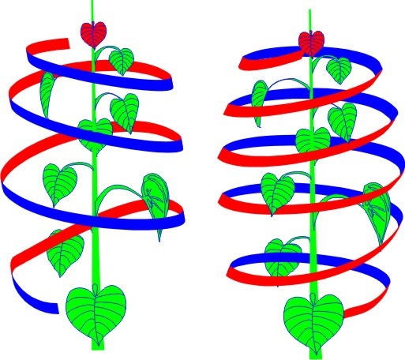Plants use a complex process called photosynthesis to extract energy from sunlight to create food. Studies on certain species have revealed that they perform yet another feat​—they calculate the optimum rate at which to absorb that food overnight.

By day, plants convert atmospheric carbon dioxide into starch and sugars. During the night, many species consume the starch stored during the day, thus avoiding starvation and maintaining plant productivity, including growth. Moreover, they process the stored starch at just the right rate​—not too quickly and not too slowly—​so that they use about 95% of it by dawn, when they start making more.

The findings were based on experiments on a plant of the mustard family called *Arabidopsis thaliana.*Researchers found that this plant carefully rations its food reserves according to the length of the night, no matter whether 8, 12, or 16 hours remained until dawn. Evidently, the plant divides the amount of starch available by the length of time remaining until dawn, thus determining the optimal rate of consumption.

You may agree with me when I say the mathematical ability of plants reflect the complexity of their design. A testament to the designer’s grand intelligence in performing an orchestration of intricate necessities of plant life.

Speaking of plant life, join us in Longview’s Community Garden where you can be a part of our own plant growth. You may donate monetarily, donate garden tools, and participate in various garden activities. Contact Kim Owen, Marketing & Sales Dir, for more information on how you can participate.

**FEBRUARY BIRTHDAYS**

Jim Evans – **February 3rd**

Janet Normile – **February 3rd**

Harry Caraco – **February 4th**

Shirley Livingstone – **February 4th**

Joann Erb – **February 7th**

Alison Maceli **– February 10th**

Amalia Tio – **February 10th**

Sunny Kuskin – **February 17th**

Donna Sokol – **February 17th**

Barbara Wernham – **February 17th**

Hong Rumney – **February 17th**

Ruth Allen – **February 24th**

Charlotte Van Sickle – **February 24th**

Barbara Adler – **February 28th**

**NEW Residents**

Roger & Suzanne Hollands (**321**)

Charles Bender **(27)**

Beverly Coon **(31)**

Marlene Carey **(407) –** 2/6

Walter Johnson **(342)**

Leo Gideon (**415**)

Sidney Piburn (**325**)

Tessie Kuo **(336)** – 2/24

Bonnie Richmond **(22)** – 2/6

Brigitte Wilkin **(33)**

Annabelle Wood **(331)** – 3/1

Mark and Marilyn Pesesky **(228)** – 4/1

Howard & Carolyn Longhouse **(319)** – TBD

**New HIRES**

**Tulasi "Tulsi" Sisti** – RA

**Phoenix Savoie** – Dishwasher

**Shyenne Camp** – Server

**Micahaela Graham** – Resident Aide

**Michael Decker** – Facilities Director

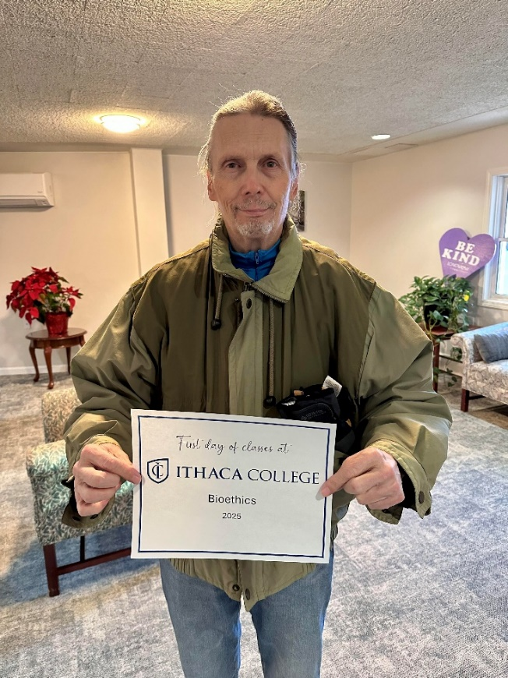

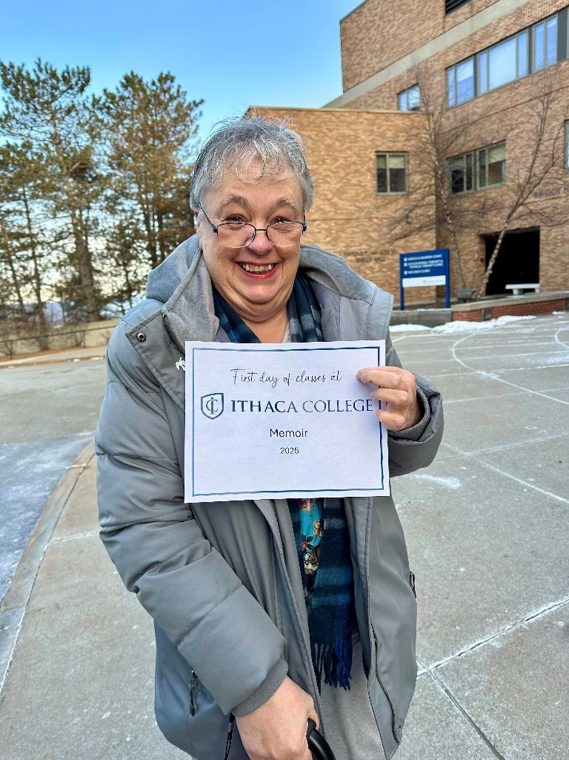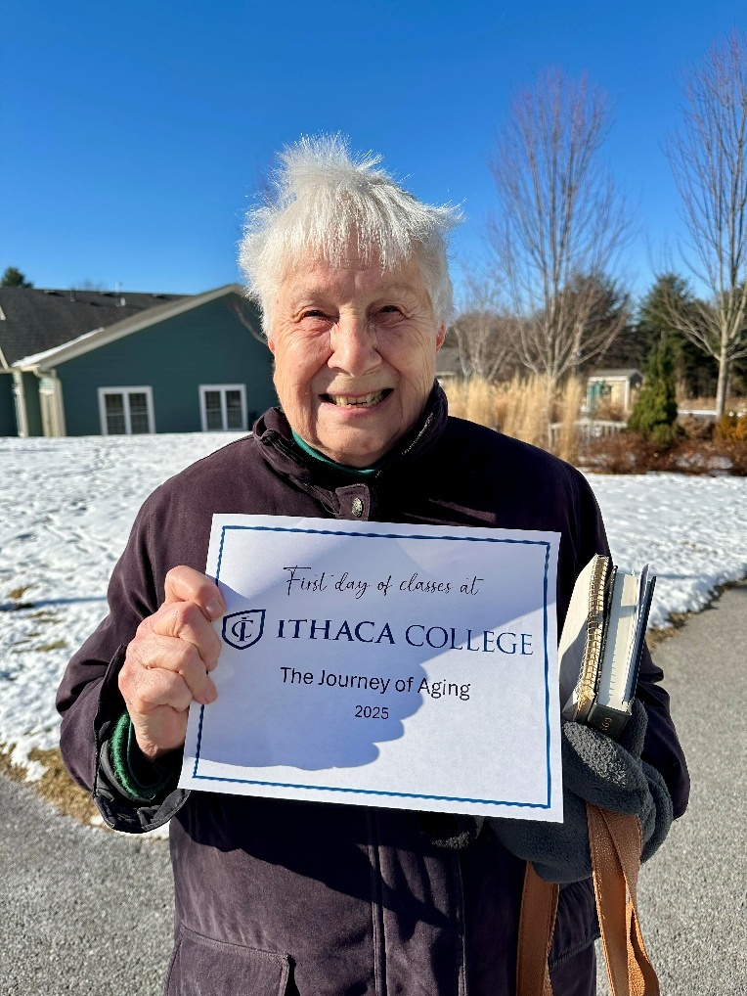

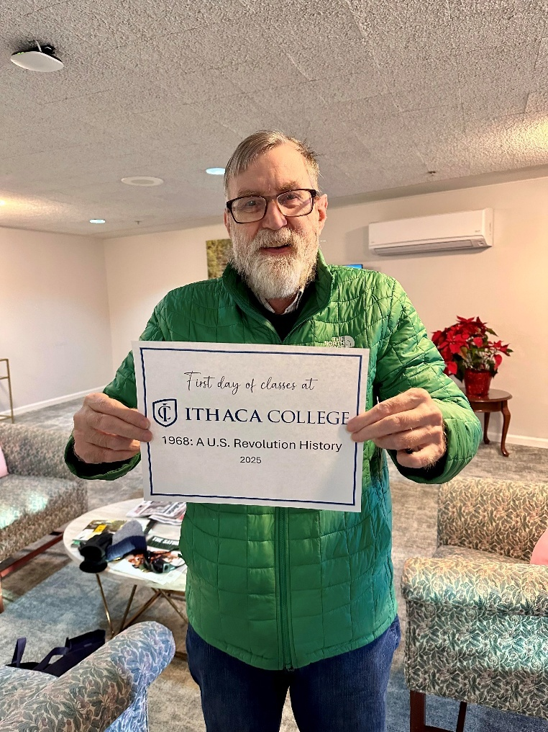

Lots of residents are taking classes this semester and are already having a blast! Make sure to speak with **Bree** in Recreation if you are interested in signing up for classes next semester in the Fall!

**Contributors**

Alissa Elghazi

Joe Haines

Bree Nash

Brooke Newell

Kim Owen

Whitney Robinson

Christina Sterling

**Creator**

Gret Atkin

**Editor**

Joe H. Zerbey VI